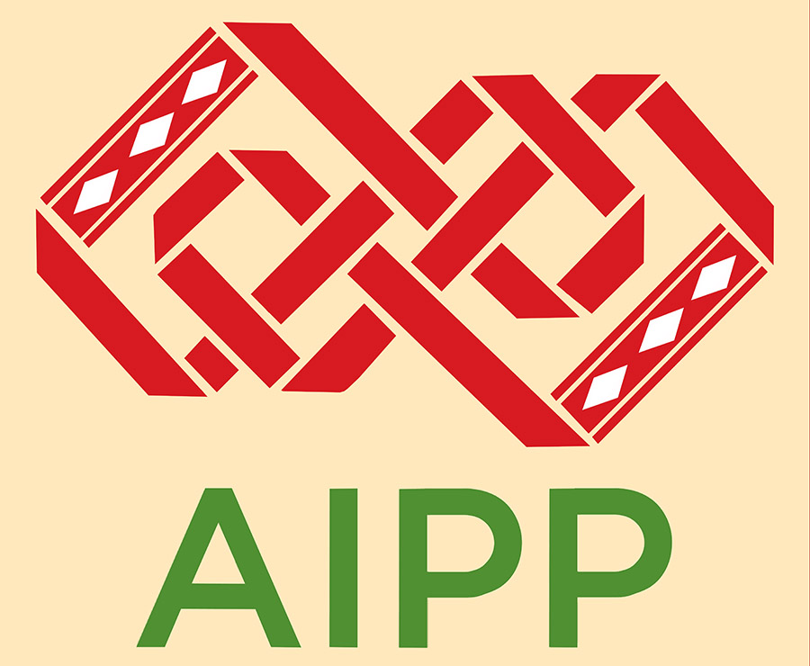

Bangladesh: Undertake a judicial investigation into Romel Chakma’s death and deliver justice immediately

10 May 2017

Forty indigenous peoples and human rights organizations, in a letter sent to Bangladesh’s Prime Minister Sheikh Hasina Wazed today, called for immediate judicial investigation into the death of Romel Chakma, who died after allegedly being tortured by Bangladesh Army officers. Further, the organizations have urged for effective justice for the death, including compensation for Romel’s family and stringent penalty for those responsible.

19-year old Romel Chakma, from Naniarchar Upazila in Rangamati was a young rights activist working for the recognition of the ethnic identity and rights of the indigenous tribes of the Chittagong Hill Tracts. Officers of 305 Infantry Brigade led by Major Syed Tanvir Saleh of Bangladesh Army had arbitrarily arrested him on 5 April on his way back home from Naniarchar Bazaar. He was then taken to the Naniarchar Zone Headquarters where the Major and Lt. Col. Bahalul Alam allegedly tortured him.

When Romel Chakma’s condition deteriorated, the army tried to hand over the dying student leader to Nanichar police station but they did not accept him due to his critical state. All along, the army did not allow the family members to even see him. He succumbed to his severe injuries on 19 April while undergoing treatment.

Body of Romel Chakma forcibly taken from family

Following Romel Chakma’s death, an unnatural death case was filed with police in Chittagong on April 19. The police handed over Romel Chakma’s dead body to his relatives in Naniarchar bazaar in the night of 20 April. However, immediately after, army officers came and forcibly took away the body from the relatives while they were taking the body home by boat. The body was kept at a shop in Burighat bazaar under army custody the whole night.

The army took the body to the jungle nearby the bazaar the following day and burnt it to ashes with petrol. Few local authorities’ representatives and two uncles of the deceased were present when the body was burnt in the presence of a Buddhist monk, whom the army had picked up from Mohalchar of Khagrachari. Romel Chakma was thus cremated without proper funeral and religious rites.

While the army has confirmed that they had arrested Romel Chakma in connection with two cases filed over torching a truck and looting two buses, they have also claimed that Romel Chakma was handed over to Naniarchar police the same day, which the police station in-charge has denied saying that they only took Romel Chakma’s dead body after post mortem on April 19. The army has also falsely claimed that Romel Chakma’s funeral was undertaken in presence of his family members in Hatimar village under police supervision

Protests across Bangladesh

Romel Chakma’s death has sparked protests across Bangladesh with various student organizations and political bodies calling for actions against those responsible. On 23 April, Rangamati Police has begun investigation into the death but only focusing on identifying the cause of death. However, even after almost three weeks since the death, Bangladeshi authorities have not ascertained the cause of death – let alone identifying and arresting those responsible.

In relation to an application of Kanti Chakma, Romel’s father, to Bangladesh’s National Human Rights Commission filed on 6 April demanding justice over his son’s arbitrary arrest, the Commission, on 23 April, has formed a three-member fact-finding committee under Commissioner Banchita Chakma on Romel Chakma’s death to submit its report within 15 working days. The committee is still investigating the death.

Call on Government of Bangladesh

Various civil society and human rights organizations and student groups have condemned the unlawful arrest and death of Romel Chakma due to torture and demanded, among others, a judicial investigation into the death. In the letter signed by Asia Indigenous Peoples Pact (AIPP) and International Work Group on Indigenous Affairs (IWGIA), the organizations have joined the call on the Government of Bangladesh for immediately undertaking a judicial investigation into Romel Chakma’s death in an independent and fair manner.

They have further noted that this is not the first time Bangladesh army has been alleged for torture and killing an indigenous person in Chittagong Hill Tracts. In August 2014, Timir Baran Chakma also reportedly died from injuries due to army torture in Khagrachari district. After the post-mortem, his body was also burned to ashes after the army declared it “unidentified” and the report was never revealed.

“We urge that adequate mandate and authority for judicial investigation into Romel’s death should be provided so as to ensure that all facts relating to the death are examined and revealed,” said Gam A. Shimray, AIPP’s Secretary General. “The investigation should lead to effective justice for the death, including moral and financial compensation to the family and penalty against the culprits.”

Torture killings are among many other abuses, including arson, sexual violence, extra-judicial killings, that the Bangladesh army allegedly undertakes in Chittagong Hill Tracts, where majority indigenous populations live. This is particularly concerning as Bangladesh army is one of the armies of the world that make the most contributions to the UN Peacekeeping Operations.

“The brutal torture and death of an indigenous activist is deeply worrying. Sadly, it corresponds with the alarming rate of discrimination and violence against indigenous activists and human rights defenders in general,” said IWGIA’s Director Julie Koch.

The organizations, in the letter, have reminded that the Government of Bangladesh is obliged to effectively investigate and redress for such abuses as per its national and international human rights obligations.

“We are not alone in our concerns on the abuses against and insecurity of the indigenous peoples in Bangladesh,” said added Koch. “It is also shared by governments such as Denmark, which raised such concern in the recently held session of the UN Permanent Forum on Indigenous Issues.”

The letter has been also copied to representatives of Danish and other diplomatic missions in Bangladesh and the UN Country Office, along with the relevant Bangladeshi ministries, Parliament and National Human Rights Commission.

For media inquiries

In Thailand,
Prabindra Shakya, Human Rights Campaign and Policy Advocacy Programme Coordinator, AIPP, prabin@aippnet.org, +66903197751

In Denmark,
Signe Leth, Asia Programme Coordinator, IWGIA, sil@iwgia.org, +4535270503

AIPP is a regional organization founded in 1988 by indigenous peoples’ movements and organizations with 48 members from 14 countries in Asia, including in Bangladesh. It is committed to the cause of promoting and defending indigenous peoples’ rights and based in Chiang Mai, Thailand.

IWGIA is an international human rights organization defending indigenous peoples’ rights based in Copenhagen. For almost 50 years, it has documented the fight for indigenous peoples’ rights by working through a global network of indigenous peoples’ organizations and international mechanisms. It promotes the recognition, respect and implementation of indigenous people’s rights to land, cultural integrity and development on their own terms.

